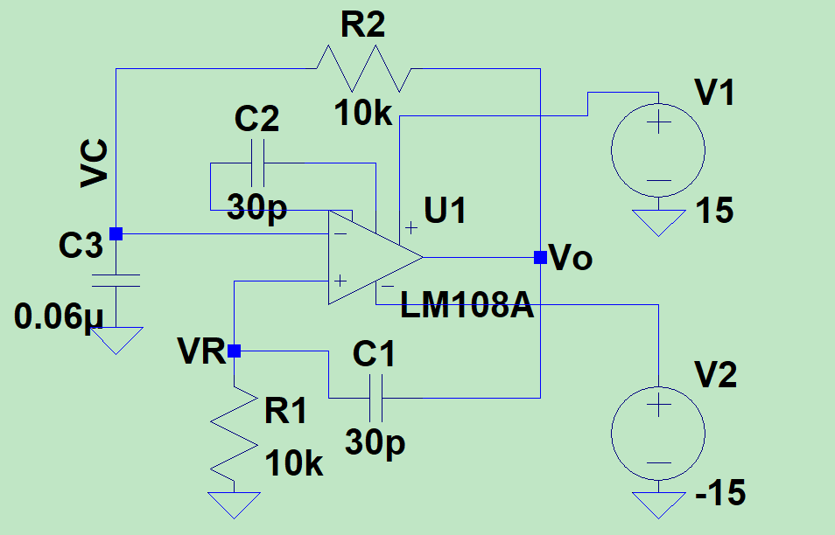

The function of this given circuit can be determined if we can find out why do C2 is used, even though there is a positive feedback thus making U1 unstable.

- As we know C2 plays crucial role in reducing the slew-rate(SR = I/C2 when I is input stage bias current), thus giving us positive and negative ramp voltage at Vo(because U1 is unstable), which is basically a unsymmetrical triangle waveform.
- The second thing is to notice that R2 and C3 form an unideal integrator with cutt-off freq of 1/(C3xR2). Hence, when we feed Vo triangle into integrator we get negative and positive paraboloid, which can be seen as imperfect sinusoidal waveform.
- The third note, is C1 and R1 forms and differentiator with cutt-off freq of 1/(C1xR1). Thus, by applying Vo triangle waveform we get Square waveform at VR

